Simple Linear Regression
Let’s now understand Simple Linear Regression through an example.
Suppose we have data from the final-year students of a Universities who were awarded scholarships. The dataset has only two columns:
- The CGPA of each student
- The Scholarship package they received (in LPA – Lakhs Per Annum)
Our task is to build a model using Linear Regression that, given a student’s CGPA, can predict their expected scholarship package.
Think of it like this: if we put this model on a website, a student can enter their CGPA, and the site will predict the package they might get.
Now imagine you don’t have any data at all. If someone asks you about the scholarship package for a student with CGPA 3.5, you could only guess (average of scholarships). For example, you might randomly say 3.5 LPA—but that’s not accurate. The answer would vary widely depending on the student’s actual abilities, interview performance, and the recruiting company.
This is why data is important. When you collect Scholarship data for all students, you can start plotting it.

Plotting the Data
When you plot the data points:
- The X-axis represents CGPA.
- The Y-axis represents the salary package.
You will notice that the data doesn’t form a perfect straight line. Some students with lower CGPAs may still get high scholarship packages because of strong interviews or company giving high package, while others with higher CGPAs may get lower packages because of poor interview or company giving lower package. This variation is common in real-world data.
So, the first question that comes to mind is: “Why is my data not perfectly aligned?”
The answer: Real-world data is always messy. Many other hidden factors—like company preference, skills, or personal interviews—affect the outcome. That’s why the dataset will not always fit a neat mathematical formula.

Drawing the Best Fit Line
If data is completely linear, then we can get a line that passes via all points and line equation is y=mx +b, Plot CGPA on this line and get a scholarship.
In future, for a given CGPA, using line equation to predict scholarship.
Data is not completely linear in real world; due to stochastic errors, poor interview—no formula to quantify, means can not determine.
Perfect line is the one that passes via all data points.
Even though the points are scattered, we can still try to draw a line that can best fit the data..
This line is called the Best Fit line (or regression line). Best fit line is one that closely passes via all data points. If data is linear or sort of linear, then linear regression determines a best fit line on sort of linear data that passes closely via all points.
Linear regression determines the best fit line means determines such value of a and b, for which the overall error is minimized (passes closely via points)
Its equation is of the form:
y=mx+b Here, m is the slope of the line.
- b is the y intercept.
As said, Linear regression determines the line over the data, means determines the value of ‘a’ and ‘b’.
Human Intuition of Y = mX + b
Equation:
Scholarship (Y) = m × CGPA (X) + b
Linear regression finds the straight-line relationship between CGPA (X-axis) and scholarship (Y-axis).
For any new CGPA, we can calculate the scholarship by multiplying the CGPA with m and then adding b. This is how linear regression makes predictions.

Understanding the Slope (m)
- m is the slope, or weightage. It shows how strongly output attribute (scholarship) depends on input attribute (CGPA).
- If m is small → the scholarship (Y-axis) changes very little when the CGPA (X-axis) changes.
- If m is large → even a small change in CGPA (X-axis) causes a big change in scholarship (Y-axis).

Understanding the Intercept (b)
- b is the intercept.
- It represents the base scholarship when CGPA = 0.
Salary= m * experience + b
The value of y (salary) for fresh graduates will be b when input variable-- experience (x) =0

Scholarship Example
Think of b as the minimum fixed scholarship a university gives to every student, no matter what their CGPA is.
- For example: “Every admitted student automatically gets $1000 (this is b). On top of that, extra scholarship depends on CGPA (m × CGPA).”
- So even if a student’s CGPA = 0, they still get $1000 → that’s the intercept.

🚖 Taxi Fare Analogy
A taxi fare usually has:
- a base charge (just for sitting in the cab) → this is b
- plus an extra charge per kilometer → this is m × distance
So, even if you travel 0 km, you still pay the base fare. That’s what the intercept means.

⚡ Electricity Bill Analogy
Your electricity bill often has two parts:
- a fixed monthly charge (just for having a connection) → this is b
- plus a charge for each unit of electricity you use → this is m × units
So even if you use 0 units, you still pay the fixed charge. That’s the intercept.

The idea is not to pass the line through all points exactly, but to minimize the error—the distance between the actual data points and the predicted line. This method ensures that the line gives the most reliable predictions overall.

Conclusion
So in short, Linear Regression is a very simple algorithm whose job is to draw a straight line through scattered data points such that the overall error is minimized. (that passes closely via all data points). Once we have this line, we can use it to make predictions. For example, if a new student has a CGPA of 8.0, we can plug this value into the equation of the line to estimate their expected salary package.

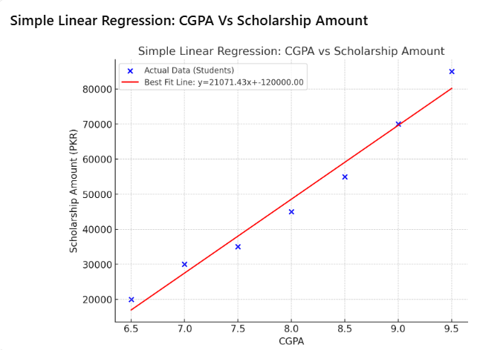
Here’s the scatter plot with a regression line for the example of CGPA vs. Scholarship Amount.
- Blue dots represent actual student data (CGPA vs. scholarship).
- The red line is the best fit line (Linear Regression), which can be used to predict scholarship amounts for new students based on their CGPA.

Predicting Home Prices Using Linear Regression
- collected data on home prices based on the areas in Monroe Township, NJ.
- With this data, construct a machine learning model called linear regression
- LR will predicting homes prices with areas of 3,300 and 5,000 square feet.

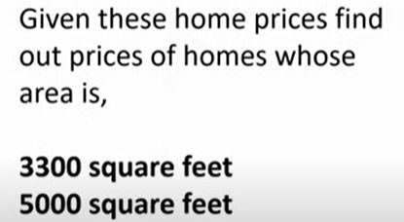

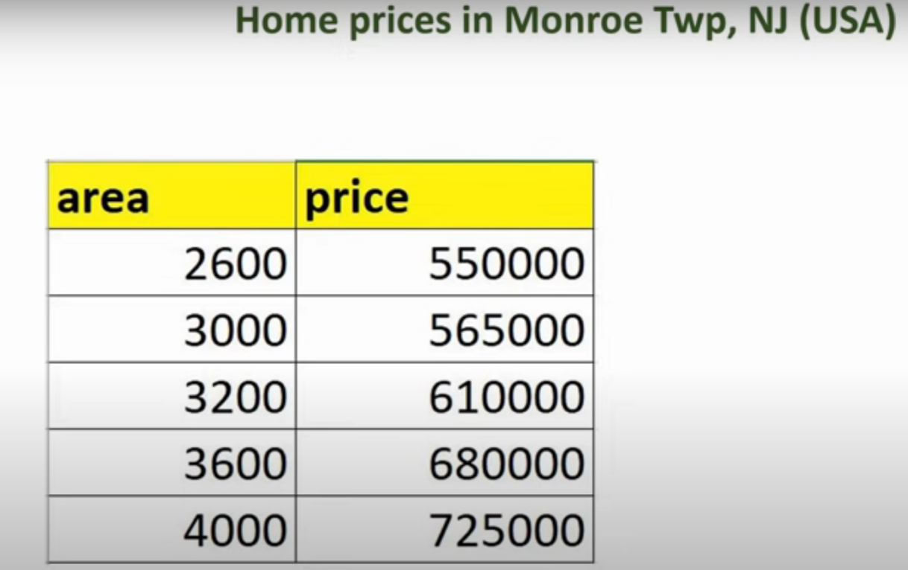

Data Visualization
- Visualize the available prices and areas with a scatter plot, where the red marker represents the data points.
- We'll then draw a blue line that best fits these data points.
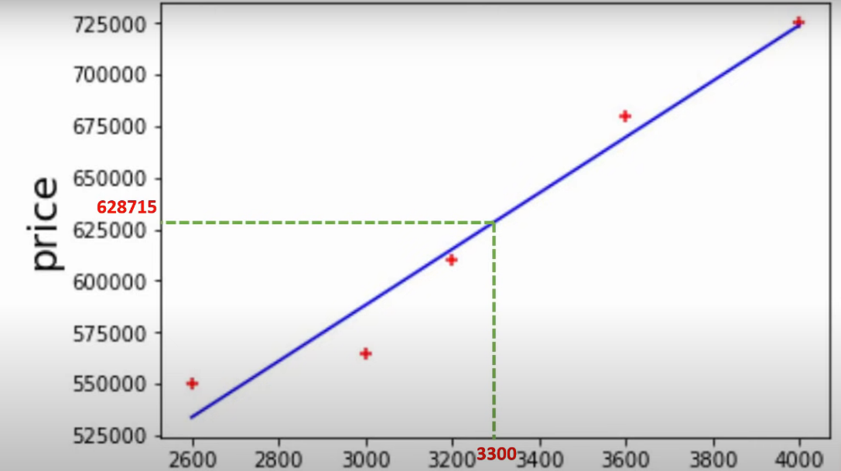
Purpose of the Blue Line
• Function: The blue line (represents a linear equation) estimate home prices for given areas.
• Example:
- Predict price for 3,300 sq. ft. Home based on linear equation (Blue Line)
- Predict price for for 5,000 sq. ft. Home based on linear equation (Blue Line)

Choosing the Best Fit Line
- Problem: Many lines (e.g., red, orange) can be drawn in number of ways
- Solution:
  - Calculate errors (ΔDeltaΔ) between actual data points and points predicted by linear equation.
  - square individual errors, sum them up and then then try to minimize
  - We do this procedure for each line (red, orange, blue)
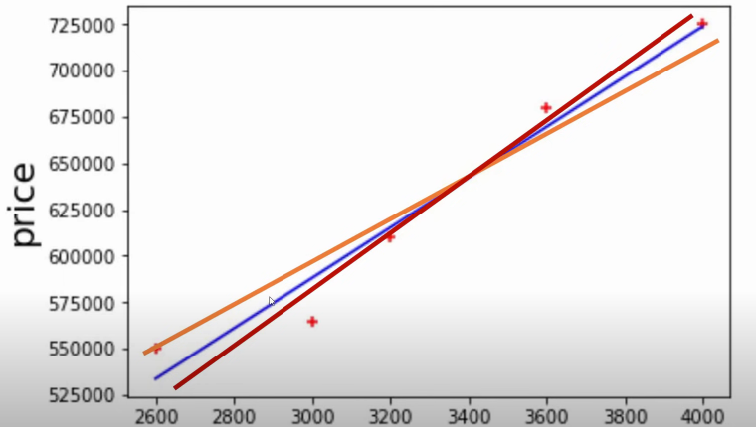

Minimizing Error
- Approach:
  - Minimize the total squared error.
  - Blue line is selected because found that it minimizes errors effectively ( better than others.)
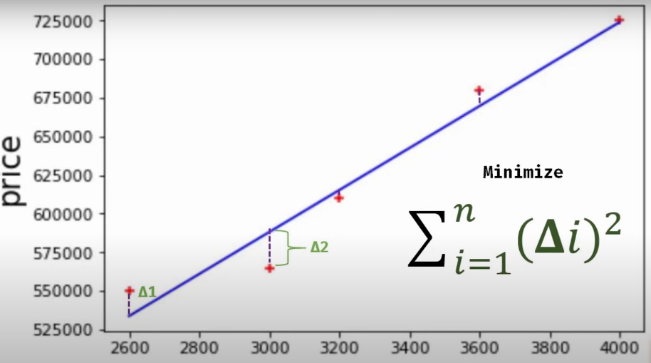
Area
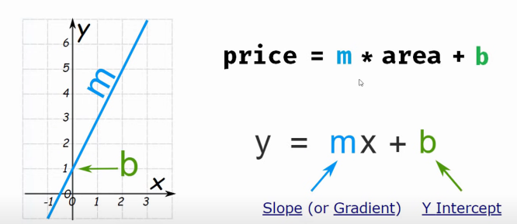
Linear Equation looks like Y=mx +b
•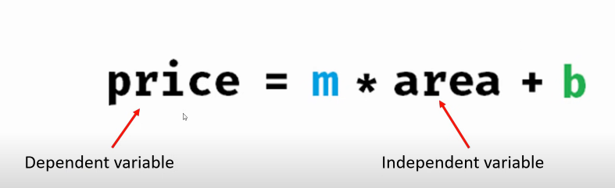

- We calculate price based on area, y=price, x= area.
- 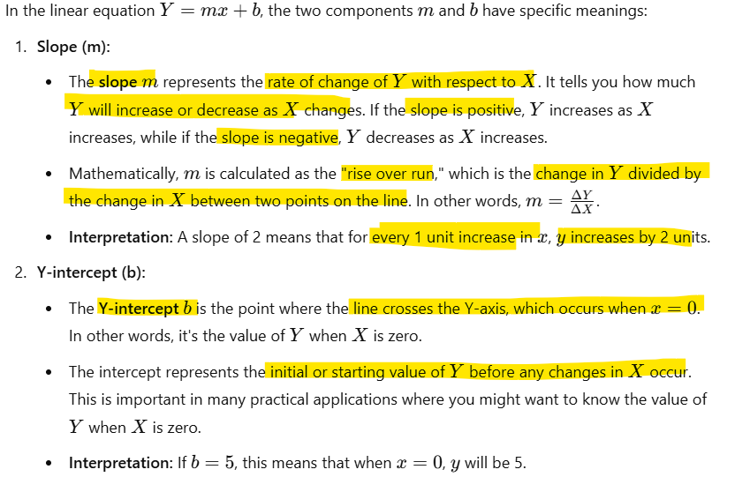

- Linear regression helps in estimating continuous values like home prices.
The best fit line minimizes prediction errors using mathematical optimization.

A scatter plot is a type of graph that shows the relationship between two variables using dots (points).
- The x-axis represents one variable (e.g., student’s CGPA).
- The y-axis represents another variable (e.g., scholarship amount).
- Each dot on the graph represents one observation (e.g., one student’s CGPA and their scholarship).

Example:
If a student has CGPA = 8.0 and received a scholarship = 60,000 PKR, you would place a dot at the point (8.0, 60,000) on the graph.
When you plot many such students, you get a cloud of points. That cloud (scatter of points) is called a scatter plot.
It helps you visually see:
- Whether there’s a relationship (e.g., higher CGPA = higher scholarship).
- Whether the relationship looks linear (points roughly forming a line).
- Whether there are outliers (points far away from the general trend).
That’s why scatter plots are the starting point for algorithms like Linear Regression — you can visually check if fitting a line makes sense.

